**Module 2**

**Assignment 1**

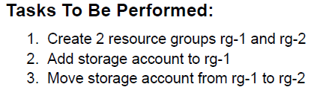

1. Create 2 Resource Groups

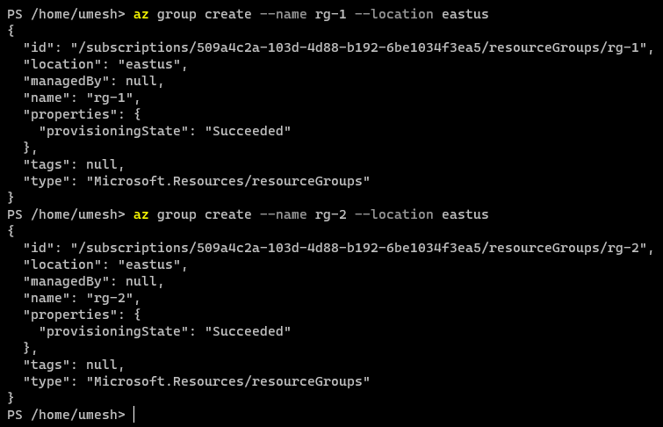

1. Add Storage to rg-1

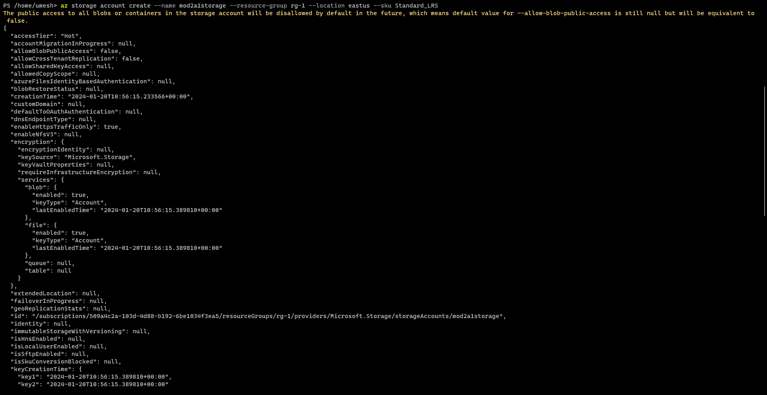

1. Move from rg-1 to rg-2
   1. To move, go to rg-1 and select storage account and move option.

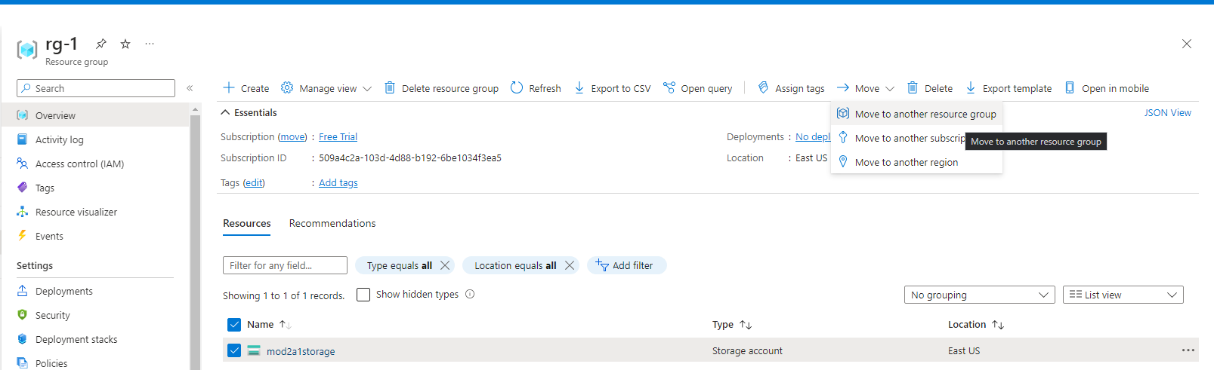

* 1. Select rg-2

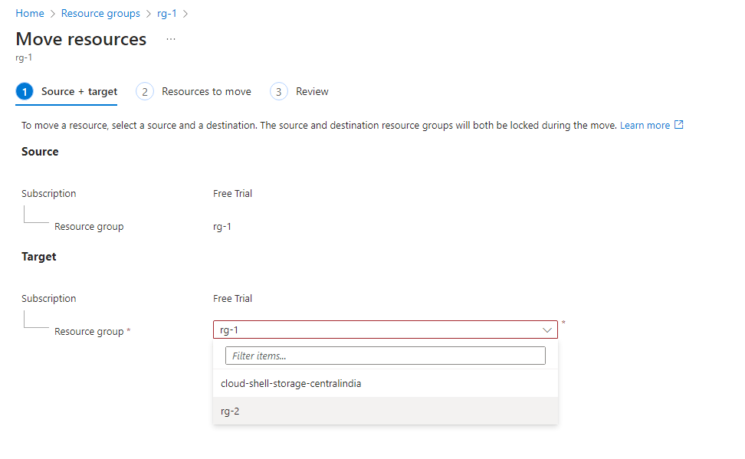

* 1. Move to rg-2

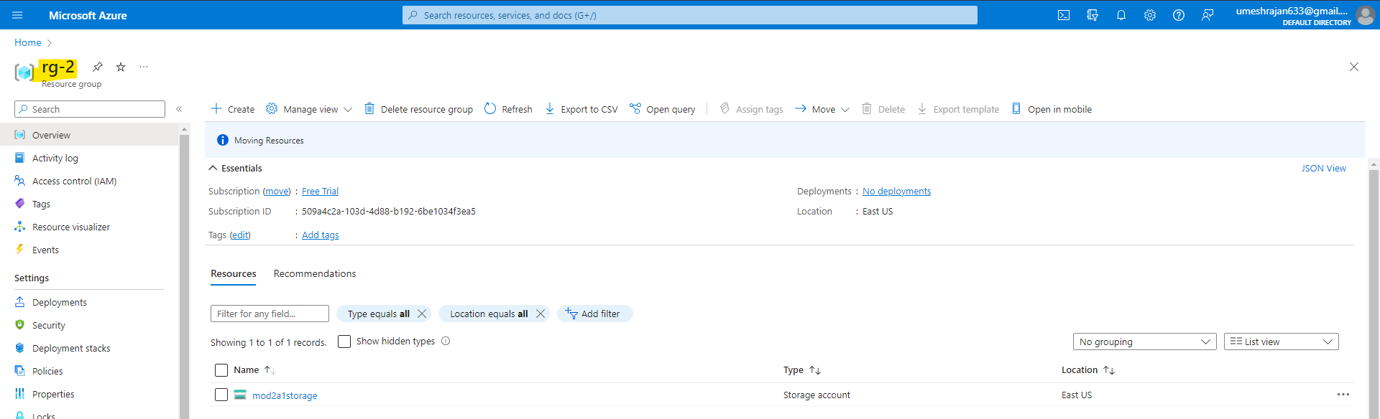

**Assignment 2**

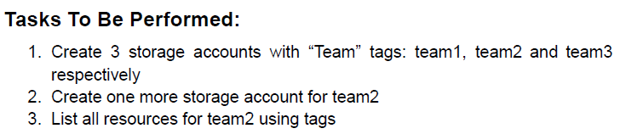

1. Create a Resource Group

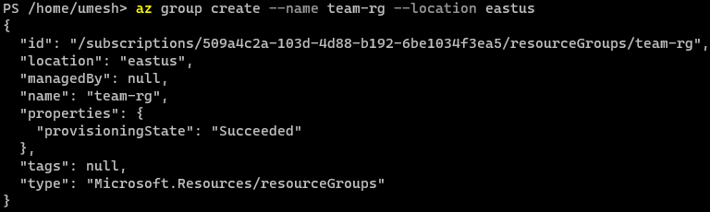

1. Then proceed to create 3 storage account inside the resource group by passing these below commands :

az storage account create --name mod2a2azstrg1 --resource-group team-rg --location eastus --sku Standard_LRS --tags Team=team1

az storage account create --name mod2a2azstrg2 --resource-group team-rg --location eastus --sku Standard_LRS --tags Team=team2

az storage account create --name mod2a2azstrg3 --resource-group team-rg --location eastus --sku Standard_LRS --tags Team=team3

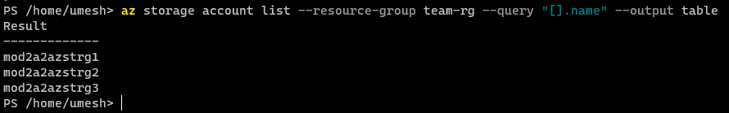

1. Create one more storage account for team 2.

az storage account create --name mod2a2azstrg2dot1 --resource-group team-rg --location eastus --sku Standard_LRS --tags Team=team2

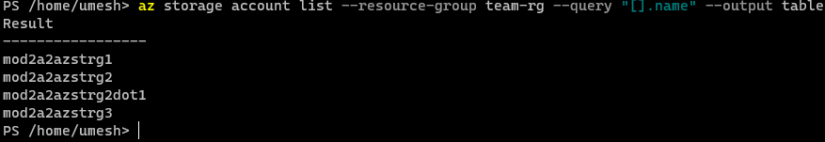

1. List the resources for team2 using tag.

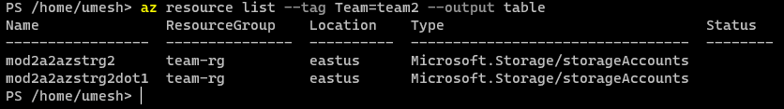

**Assignment 3**

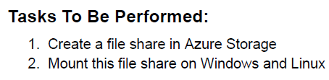

1. Navigate to Azure Storage Account and click on Create.

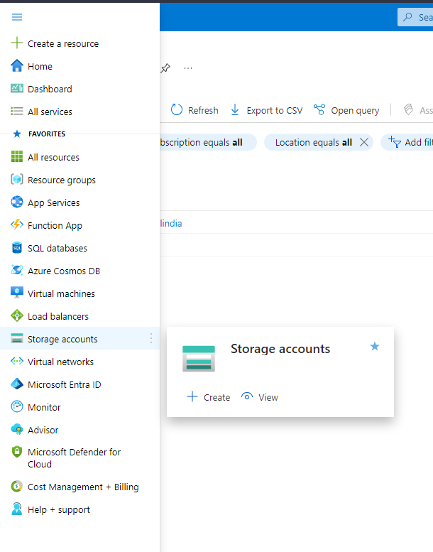

1. Navigate to File Shares and Create a File Share

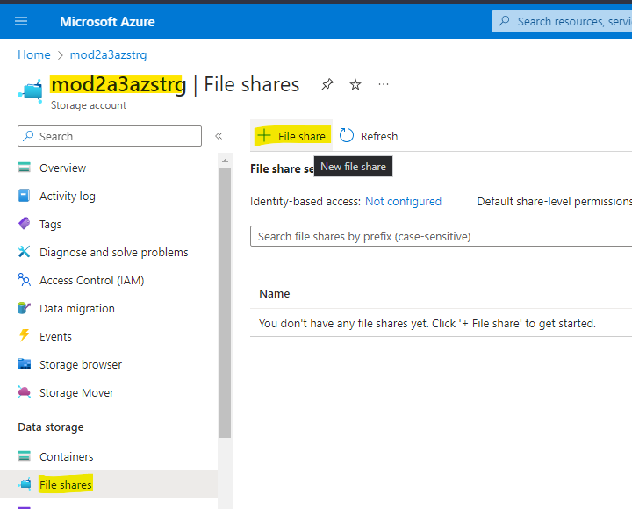

1. After creating File Share, Copy one of the Access Key.

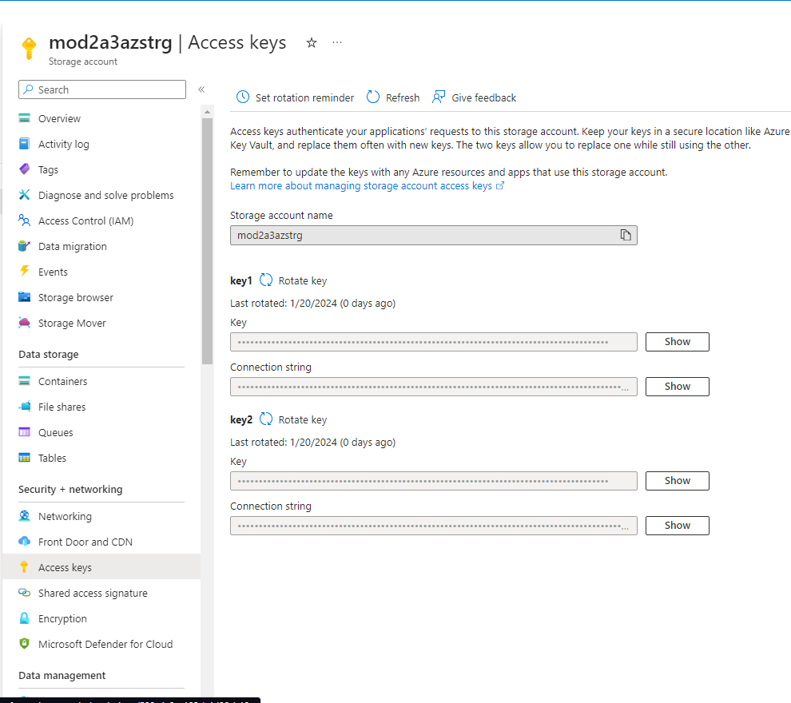

1. Access File Share from Window and Linux :
   1. Windows :
      1. Map Network Drive

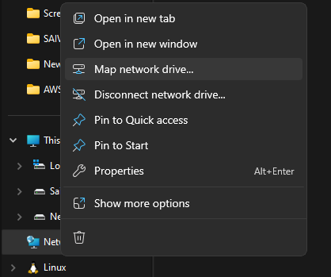

* + 1. It will ask you for credentials, for username pass the storage account name and the copied access key for password.
    2. Connected to the File Storage via Windows

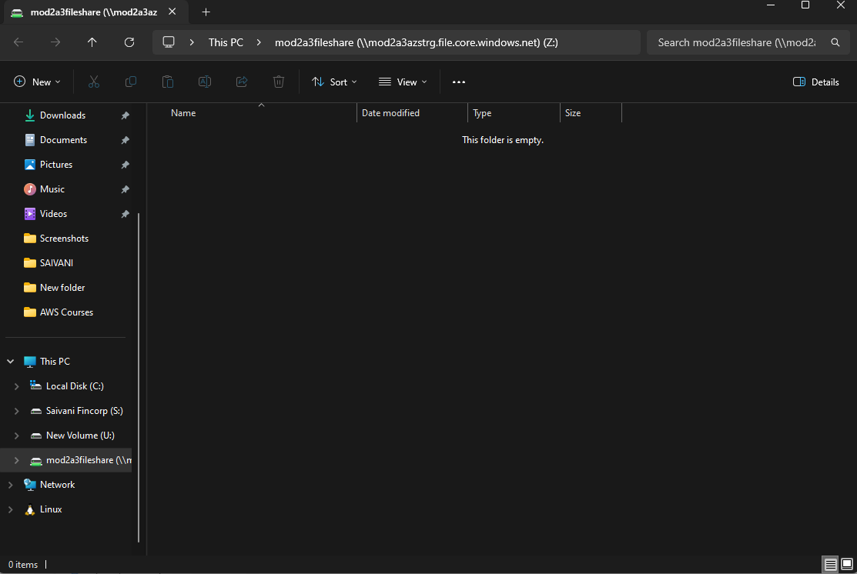

* 1. Linux :
     1. Install the cifs-utils package
     2. Create a new directory and copy the directory path to mount.
     3. Execute the below command and create a file once connected to test the connectivity :

sudo mount -t cifs //mod2a3azstrg.file.core.windows.net/mod2a3fileshare /home/ubuntu/azstoragetest -o vers=3.0,username=mod2a3azstrg,password=<copied_access_key>,dir_mode=0755,file_mode=0664

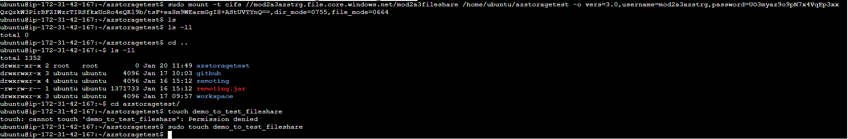

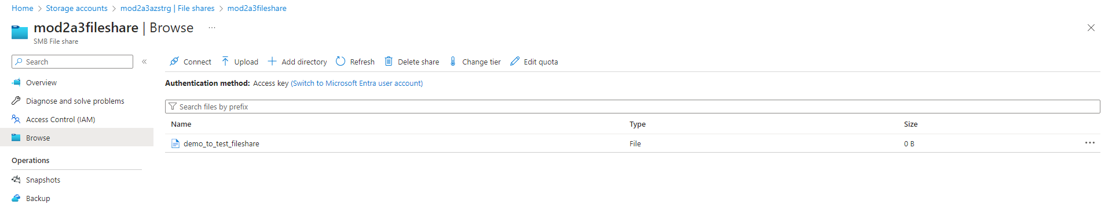

**Assignment 4**

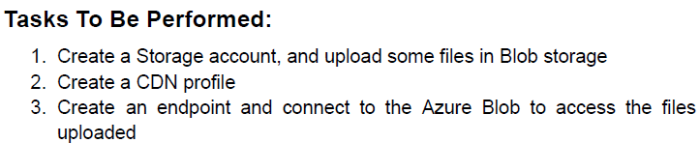

1. Create a Storage Account

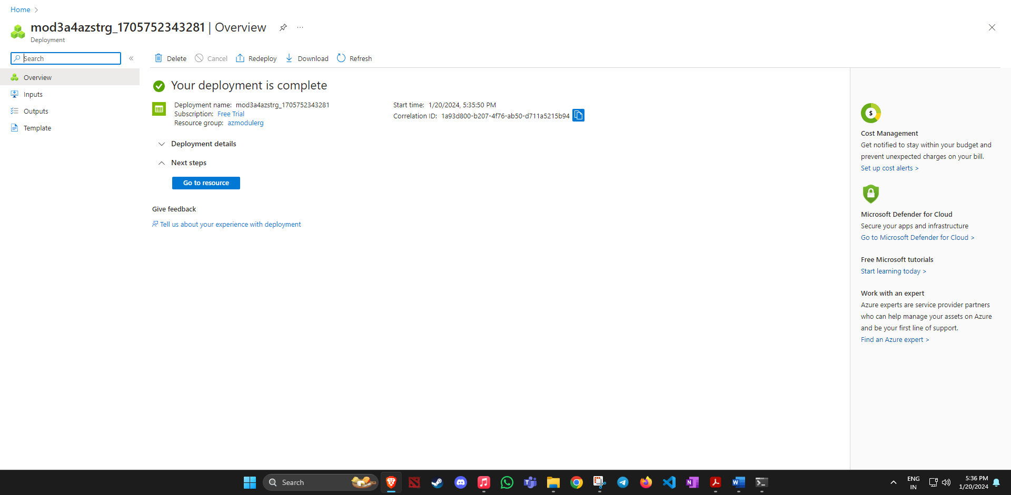

1. Create a Container

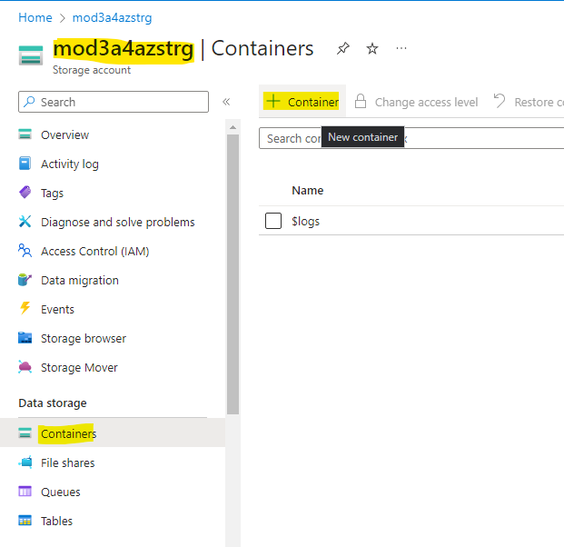

1. Once the container is created, upload a file.

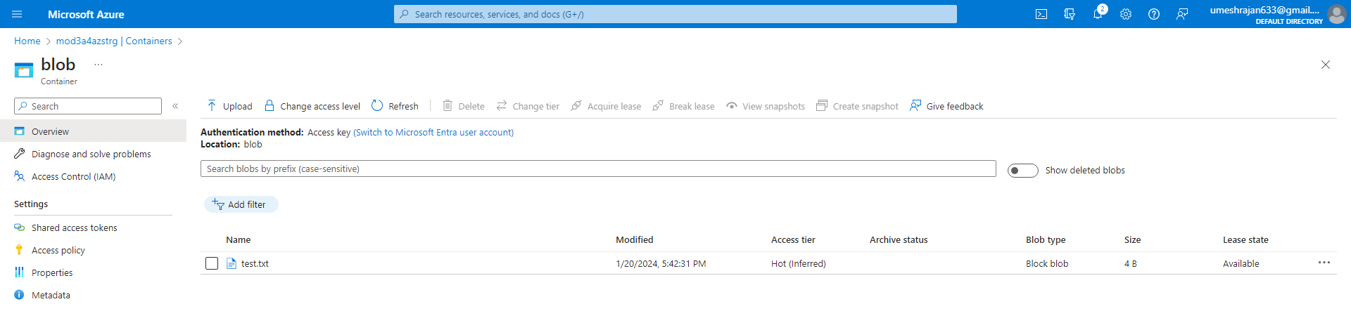

1. Create a CDN

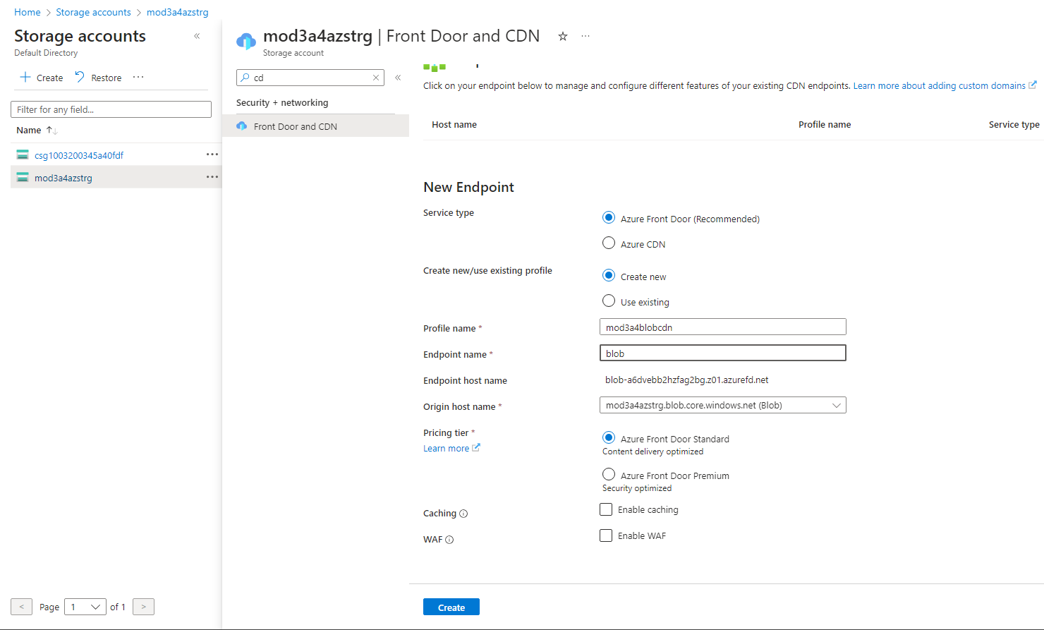

1. Once created, add an endpoint and connect to azure blob to access the files.

**Assignment 5**

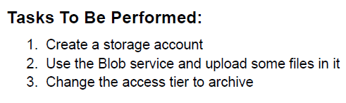

1. Create a Storage Account



1. Create a Container



1. Once the container is created, upload a file.



1. Change the access tier to archive

